2D Survival Shooter

Name: DISSANAYAKA D.U.C.
IT Number: IT22577788

Contents

- Summary of the Game Concept 3
- Description of the Game 3
- Screenshots of Gameplay 3
- Control Guide 3
- Description of the Creative Feature 4
- Credits (External Assets / Tools) 4
- Gameplay Video 4
- Final Notes 4

Summary of the Game Concept
This is a simple 2D survival shooting game where the player controls a character inside a bounded area. Enemies continuously spawn from one side and move toward the player. The objective is to survive as long as possible by shooting enemies while avoiding damage.
The player gains points by destroying enemies and loses health when colliding with them. The game ends when the player’s health reaches zero.

Description of the Game
The game is developed using Unity 2D. The player is placed inside a rectangular arena surrounded by walls. Enemies spawn periodically from the right side and move toward the left.
The player can:
- Move in all directions using keyboard input
- Shoot projectiles using the mouse
- Destroy enemies to gain score
If an enemy collides with the player:
- The player's health decreases
- The enemy is destroyed
If a projectile hits an enemy:
- The enemy is destroyed
- The player gains score
The game stops when health becomes zero and displays a "Game Over" message with restart option.

Screenshots of Gameplay
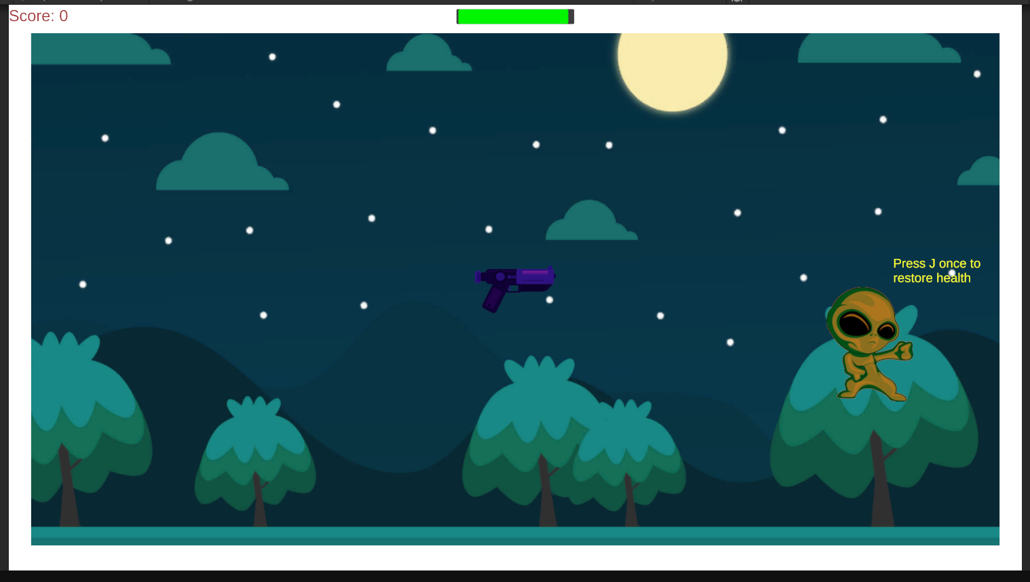
Game Start Screen
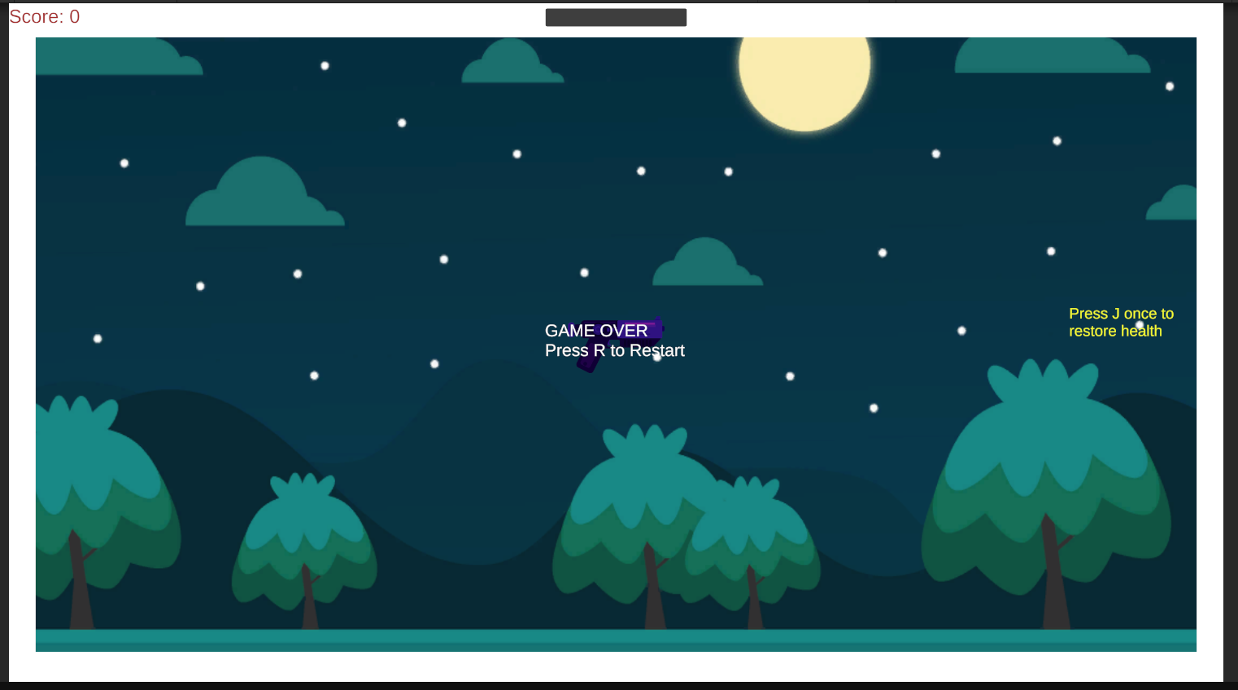
Game Lose Screen
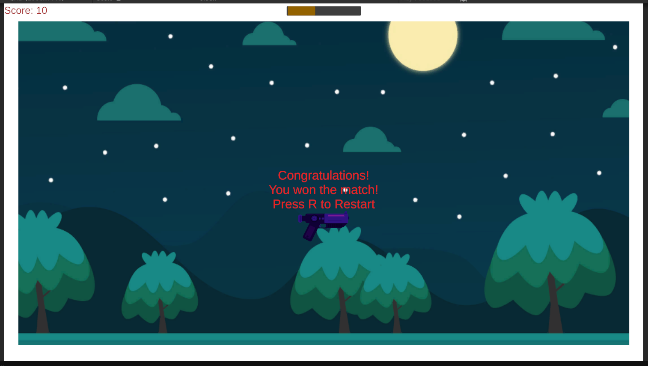
Game Win Screen

Control Guide
Action | Input
Move Player | Arrow Keys / WASD
Shoot | Left Mouse Click
Restart Game | R key
Quit Game | Q key

Description of the Creative Feature
The creative feature implemented in this game is the real-time scoring and health system with game state control.
Key highlights:
- Dynamic enemy spawning system
- Health bar with color indication (green → yellow → red)
- Game freeze using Time.timeScale = 0 on Game Over
- Restart system without restarting application
- Smooth projectile-based shooting system
These features enhance gameplay experience and provide interactive feedback to the player.

Credits (External Assets / Tools)
- Game Engine: Unity 6 (Unity 2D)
- Programming Language: C#
- Sprites: Default Unity Sprites (Square, UI elements)
- UI System: TextMeshPro (Unity)
- Development Tool: Visual Studio

Gameplay Video
Video Link: Click here

Final Notes
This project demonstrates fundamental game development concepts including:
- Player movement
- Collision detection
- Enemy AI movement
- Shooting mechanics
- UI updates (score & health)
- Game state management

